University of Engineering and Technology, Lahore
Name: Maria Abbas
Reg No: 2026(S) CYS_61
Department: Computer Engineering
Degree: Cyber security
Section: B
Assignment: PF Lab week 4
Date: 23 March 2026
CLO1

Lab Tasks
Nested loops
Task 1
This programme uses a nested for loops to track and print value of variables (i) and (j) together

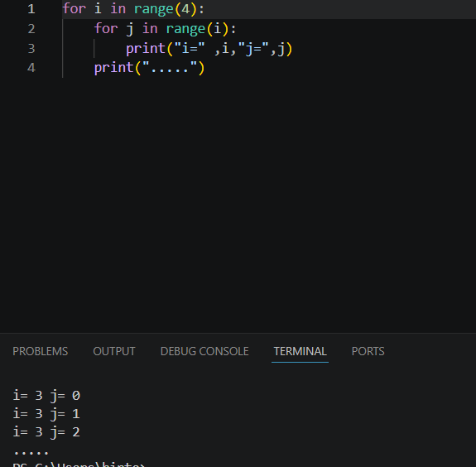
Task 2:
This programme uses nested for loop to print pair of numbers like coordinates. It highlights how inner loop repeats inside the outer loop to generate structure pattern.
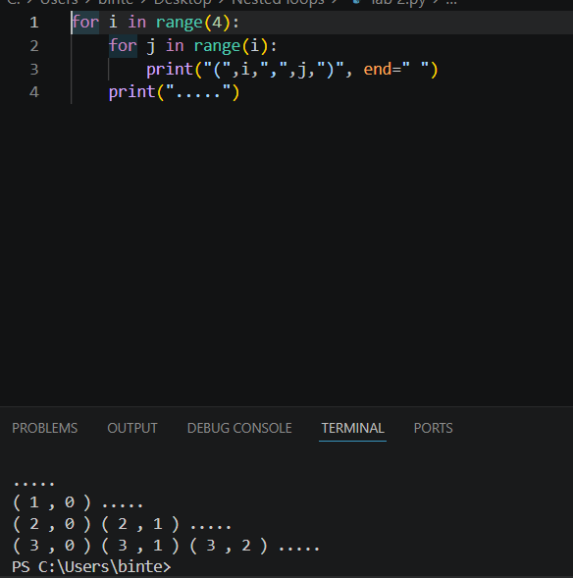
Task 3:
This programme use nested for loop to print a growing pattern numbers on screen.
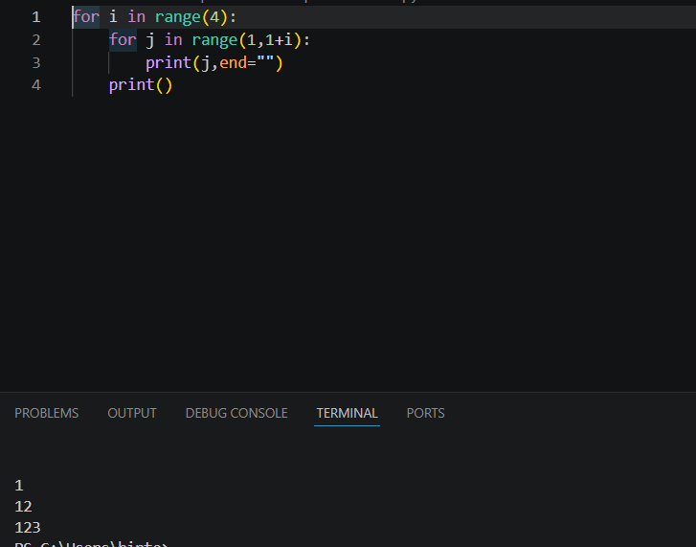

Task 4:
This programme creates a centered star pyramid. The outer loop controls the rows while inner loop manage spacing.
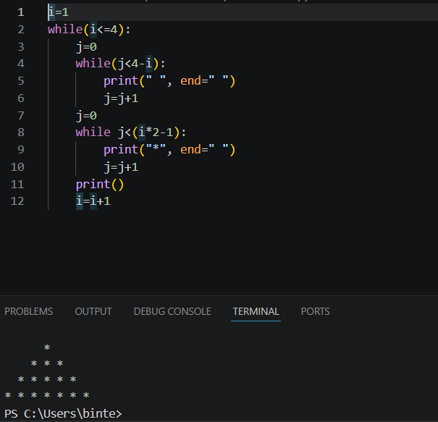
Task 5:
This programme uses nested loop to generate and print combination of numbers between 1 and 4.It demonstrates how an inner loop runs its full cycle for every single iteration of outer loop.
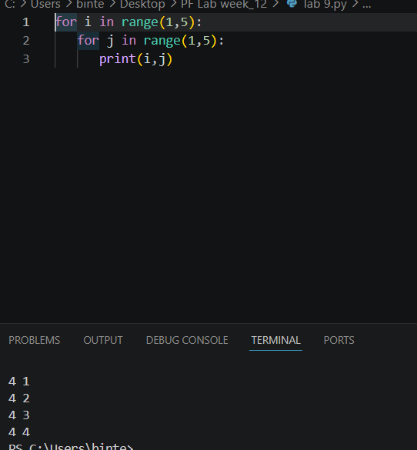
Task 6:
This programme uses nested loop to print fewer stars.
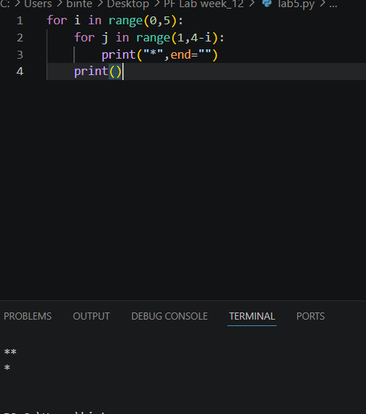
Task 7:
This programme uses nested loop to create simple right-side angle star triangle. The outer loop handles the row count while inner loop prints increasing number of stars row by row.
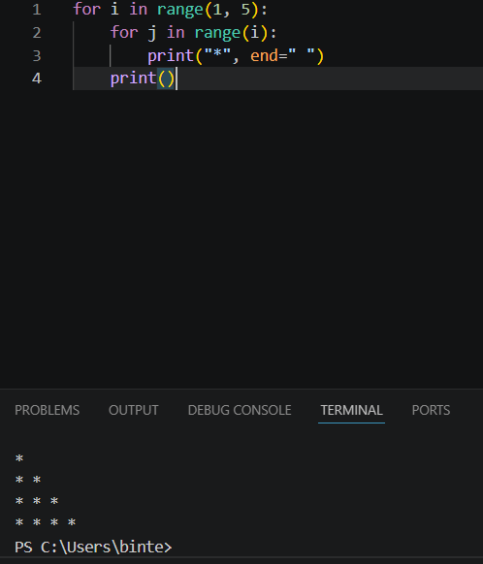

Task 8:
This program uses nested *for loops* combined with an if condition to print a growing triangle of repeating numbers. The inner loop checks the row value to print the current line's number multiple times.

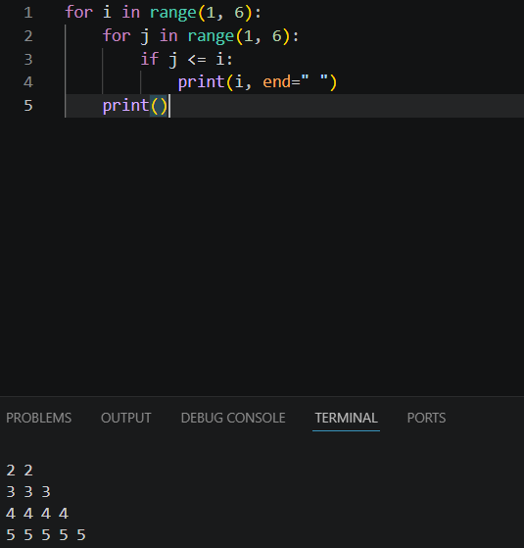
Task 9:
This program uses two separate sets of nested *for loops* to create a sideways diamond star pattern. The first part handles an increasing star pattern, while the second part handles a decreasing star pattern.
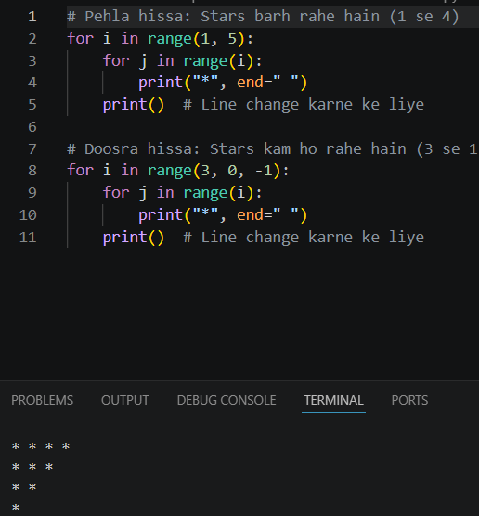
Task 10:
This program prints consecutive numbers in a triangle pattern using nested loops.
The variable num increases by 1 after every number is printed.
